Economics
Home Learning Pack Challenges

Please find attached a pack of work to help prepare you for sixth form.

I am delighted that you have shown an interest in economics. In order to get you thinking about the subject, I have drawn up a challenge pack to help you prepare for studies in the 6th form such as research activities, books to read, films to watch on a rainy afternoon, useful websites to browse when Snapchat, Instagram gets dull.

These are activities to get you thinking about economics and just general information and interest. For any of you at a loose end there are some meaningful things that you could be doing to start thinking about next year.

For a look at the syllabus:
- Economics Specification (note we do Edexcel syllabus A which this link should take you to)
https://qualifications.pearson.com/en/qualifications/edexcel-a-levels/economics-a-2015.html

Useful websites/apps- register now:
- Register with https://www.tutor2u.net/economics, an economics blog especially written for students. A daily blog will be sent to you with interesting news articles that tie into the syllabus, comments from examiners and (later) tips and support for exam modules. There is some good general reading here and links to other websites and videos.
- https://www.tutor2u.net/economics/collections/head-start-for-alevel-economics-transition-resource-year-11-students - they also do a ‘getting started’ set of transition resources for year 11s into sixth form. Useful to dip into these.
- https://www.econplusdal.com/, a really useful revision website. Definitely no need to look at his videos yet BUT useful to follow him on facebook/twitter/intstagram at this stage.

Please email lsc@hartismere.com if you have any queries or questions.

In the meantime, I want to say a big thank you for your hard work at Hartismere or your current/previous school.

Kind regards

Mrs L Scales & Miss R Petty
Economics
Hartismere School

CONTENTS

- Link to the ‘Getting Ahead’ activities

- Home Learning Activities Challenges
- Short Answer Economics Context Questions

- Reading (Just for general awareness)
- Newspapers and magazines
- Books
- Websites

Please do sign up at ‘Tutor2U’ for their daily economics updates (use your school email address if you have one). Any articles that interest you can be looked at and possibly researched further. It will show you the variety of areas looked at over the 2 year course.

You could also dip into the tutor2U economics ‘Year 11 head start’ videos available here:
https://www.tutor2u.net/economics/collections/head-start-for-alevel-economics-transition-resource-year-11-students

Starting A-Level Economics
Much of the work we will do in economics will involve analysing real life current issues affecting households, business and society as a whole. The government will have to make many key decisions in the next few years which may have a profound effect on people`s standards of living.
Here are a few examples of these decisions, perhaps have a chat with parents/guardians and relatives about these issues, but try to develop your own opinions that you can justify! Keep response to 1 or 2 sentences


What should the government do to make houses affordable?

My response:

My response:

Should we totally ban cigarette purchases?

My response: (say yes or no and explain why):


How can we get people to eat more fruit and vegetables?

My response:

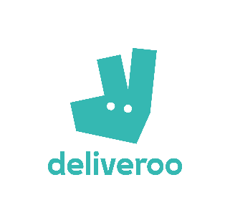
Should zero hours contracts be stopped?

My response:

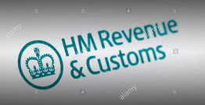
Should the government increase income tax for higher earners?

My response:
READING
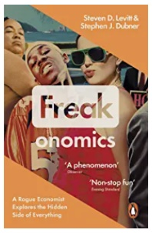
Quality newspapers/magazines such as The Times, Guardian, Telegraph, Independent, journals such as The Economist (Definitely no need to purchase/subscribe to this, you can sign up online and receive free articles.).
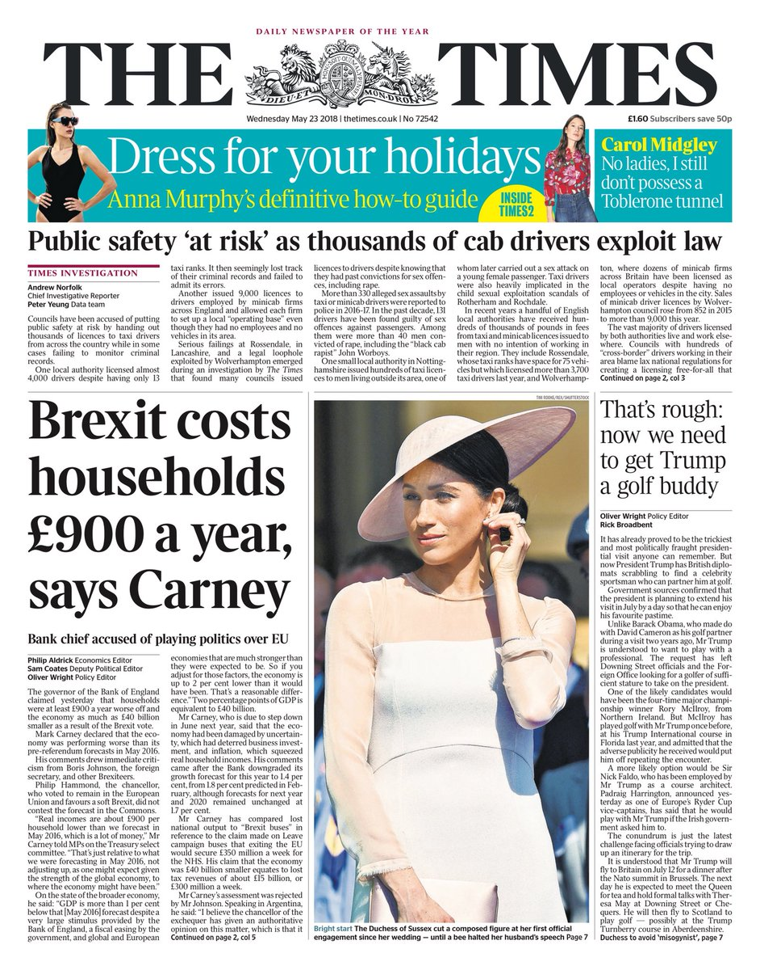  www.thetimes.co.uk | 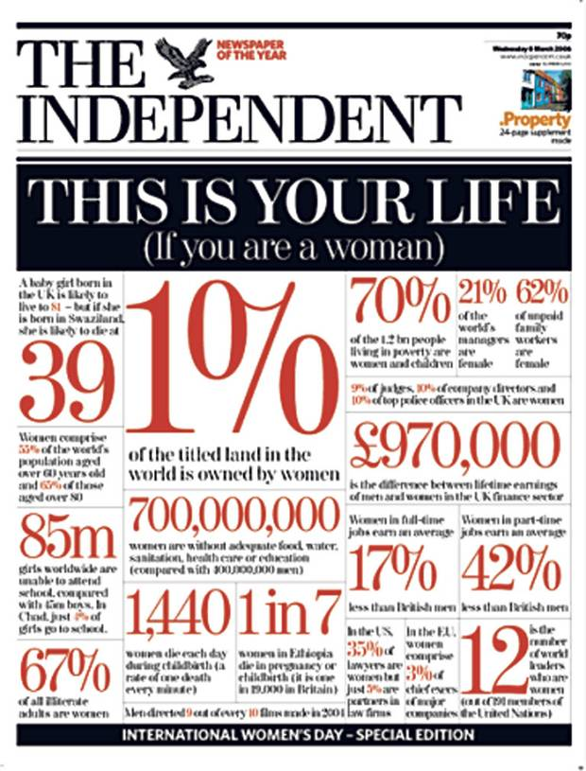  www.independent.co.uk |   www.economist.com

Economics Books (general interest to dip into NOT textbooks at this stage)
Freakonomics by Steven Levitt and Stephen J. Dubner
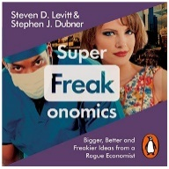
Discover the answers to the following questions: Which is more dangerous, a gun or a swimming pool? What do schoolteachers and sumo wrestlers have in common? Why do drug dealers still live with their moms? How much do parents really matter? How did the legalization of abortion affect the rate of violent crime?
SuperFreakonomics by Steven Levitt and Stephen J. Dubner
** Remember you can hear many of these for free on the freakonomics podcasts (see the link below)
The Logic of Life: The Rational Economics of an Irrational World by Tim Harford
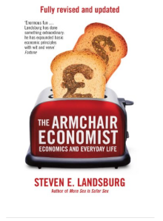
“Life often seems to defy logic. When a prostitute agrees to unprotected sex, or a teenage criminal embarks on a burglary, or a smoker lights another cigarette, we seem to be a million miles from what we would call rational behaviour. None of this makes sense – or does it? Tim Harford thinks it does. And by weaving stories from locations as diverse as a Las Vegas casino and a Soho speed-date together with insights from an ingenious new breed of economist, he aims to persuade you that we are all, in fact, surprisingly logical. Reading this book, you’ll discover that the unlikeliest of people – racists, drug addicts, revolutionaries and rats – comply with economic logic, always taking account of future costs and benefits, even if they don’t quite realise it. It even explains why your boss is overpaid…”
Also see Tim Harford's:
- The Logic of Life: The Undercover Economist
- The Logic of Life: Uncovering the New Economics of Everything
- his columns in the Financial Times
** Remember you can read many of these for free on the FT website: https://www.ft.com/undercover-economist
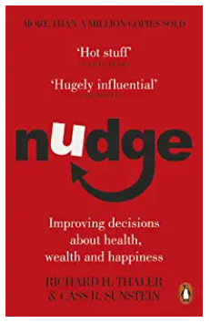
Nudge: Improving Decisions About Health, Wealth and Happiness by Richard H Thaler and Cass R Sunstein
Nudge is about choices - how we make them and how we can make better ones. Every day we make decisions: about the things that we buy or the meals we eat; about the investments we make or our children's health and education; even the causes that we champion or the planet itself. Unfortunately, we often choose poorly. We are all susceptible to biases that can lead us to make bad decisions. And, as Thaler and Sunstein show, no choice is ever presented to us in a neutral way. By knowing how people think, we can make it easier for them to choose what is best for them, their families and society. Using dozens of eye-opening examples and original research, the authors demonstrate how to nudge us in the right directions, without restricting our freedom of choice.

Recommended websites/follow on Twitter/ Apps on your mobile

  www.tutor2u.net  Excellent economics website with everything you need to learn for Business A Level, presentations, videos, revision quizzes. | www.bbc.co.uk  Excellent news website with everything you need to learn about what is going on in the world today   |   www.londonstockexchange.com  Excellent website with everything you need to learn about share prices and market capitalization.
https://freakonomics.com/    Podcasts from one of the key writers from the great series freakonomics books |   https://ig.ft.com/sites/numbers/economies/uk/  Excellent website for researching the UK economy at a glance. The FT’s one-stop overview of key economic data, including GDP, inflation, unemployment |     https://www.youtube.com/channel/UCQbBh9Jn2IjcSPZOiNKJu0g  Really useful YouTube channel with wide range of revision videos on all economics a level topics

